English
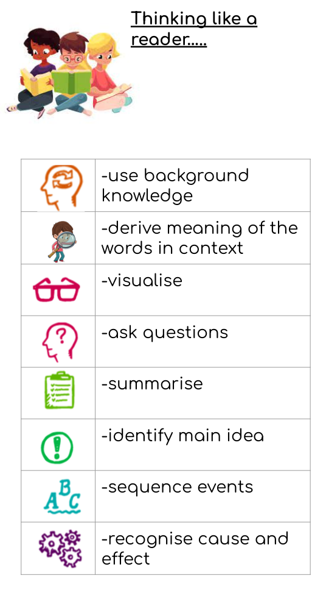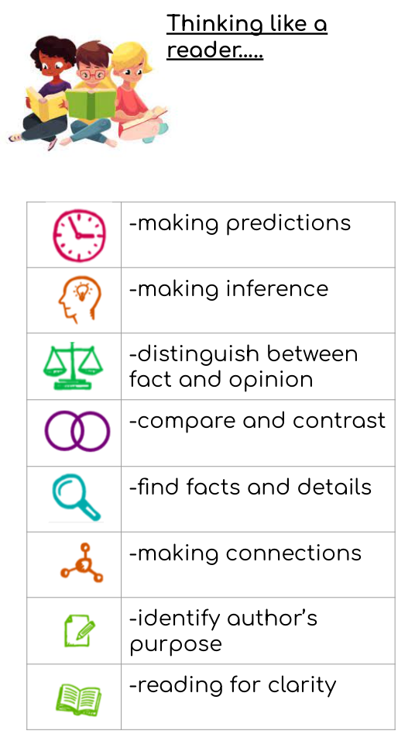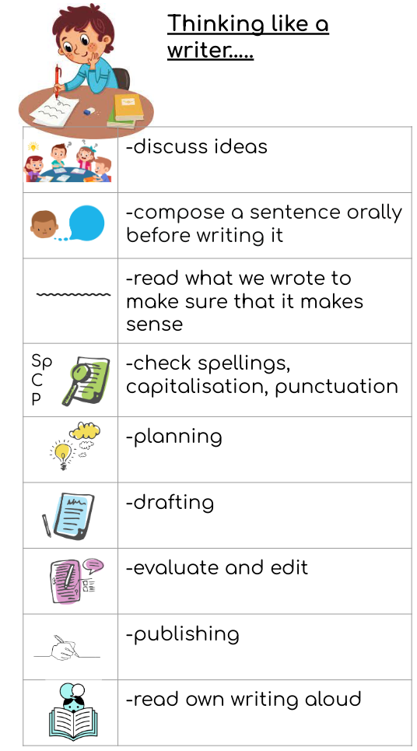

Word Reading
apply phonic knowledge and skills as the route to decode words
respond speedily with the correct sound to graphemes (letters or groups of letters) for all 40+ phonemes, including, where applicable, alternative sounds for graphemes
read accurately by blending sounds in unfamiliar words containing GPCs that have been taught
read common exception words, noting unusual correspondences between spelling and sound and where these occur in the word
read words containing taught GPCs and –s, –es, –ing, –ed, –er and –est endings
read other words of more than one syllable that contain taught GPCs
read words with contractions [for example, I’m, I’ll, we’ll], and understand that the apostrophe represents the omitted letter(s)
read books aloud, accurately, that are consistent with their developing phonic knowledge and that do not require them to use other strategies to work out words
reread these books to build up their fluency and confidence in word reading
Reading comprehension
Pupils should be taught to:
develop pleasure in reading, motivation to read, vocabulary and understanding by:
listening to and discussing a wide range of poems, stories and non-fiction at a level beyond that at which they can read independently
being encouraged to link what they read or hear to their own experiences
becoming very familiar with key stories, fairy stories and traditional tales, retelling them and considering their particular characteristics
recognising and joining in with predictable phrases
learning to appreciate rhymes and poems, and to recite some by heart
discussing word meanings, linking new meanings to those already known
understand both the books they can already read accurately and fluently and those they listen to by:
drawing on what they already know or on background information and vocabulary provided by the teacher
checking that the text makes sense to them as they read, and correcting inaccurate reading
discussing the significance of the title and events
making inferences on the basis of what is being said and done
predicting what might happen on the basis of what has been read so far
participate in discussion about what is read to them, taking turns and listening to what others say
explain clearly their understanding of what is read to them
Writing transcription
spell:
words containing each of the 40+ phonemes already taught
common exception words
the days of the week
name the letters of the alphabet:
naming the letters of the alphabet in order
using letter names to distinguish between alternative spellings of the same sound
add prefixes and suffixes:
using the spelling rule for adding –s or –es as the plural marker for nouns and the third person singular marker for verbs
using the prefix un–
using –ing, –ed, –er and –est where no change is needed in the spelling of root words [for example, helping, helped, helper, eating, quicker, quickest]
apply simple spelling rules and guidance, as listed in English appendix 1
write from memory simple sentences dictated by the teacher that include words using the GPCs and common exception words taught so far
Handwriting
sit correctly at a table, holding a pencil comfortably and correctly
begin to form lower-case letters in the correct direction, starting and finishing in the right place
form capital letters
form digits 0-9
understand which letters belong to which handwriting ‘families’ (ie letters that are formed in similar ways) and to practise these
Writing composition
write sentences by:
saying out loud what they are going to write about
composing a sentence orally before writing it
sequencing sentences to form short narratives
re-reading what they have written to check that it makes sense
discuss what they have written with the teacher or other pupils
read their writing aloud, clearly enough to be heard by their peers and the teacher
Writing - vocabulary, grammar and punctuation
develop their understanding of the concepts set out in English appendix 2 by:
leaving spaces between words
joining words and joining clauses using ‘and’
beginning to punctuate sentences using a capital letter and a full stop, question mark or exclamation mark
using a capital letter for names of people, places, the days of the week, and the personal pronoun ‘I’
learning the grammar for year 1 in English appendix 2
use the grammatical terminology in English English appendix 2 in discussing their writing

Mathematics
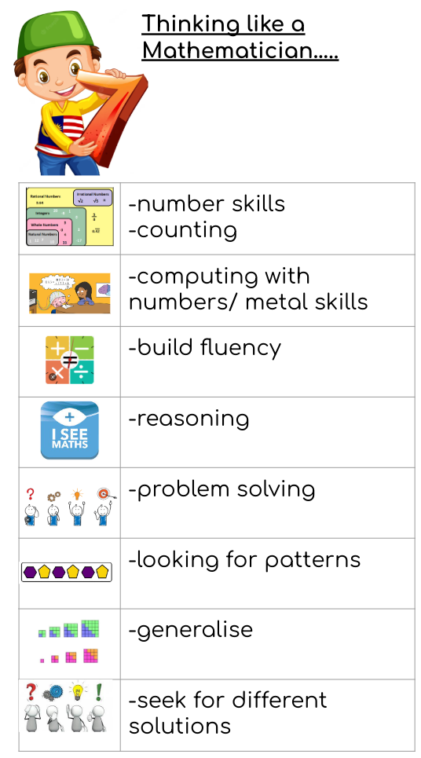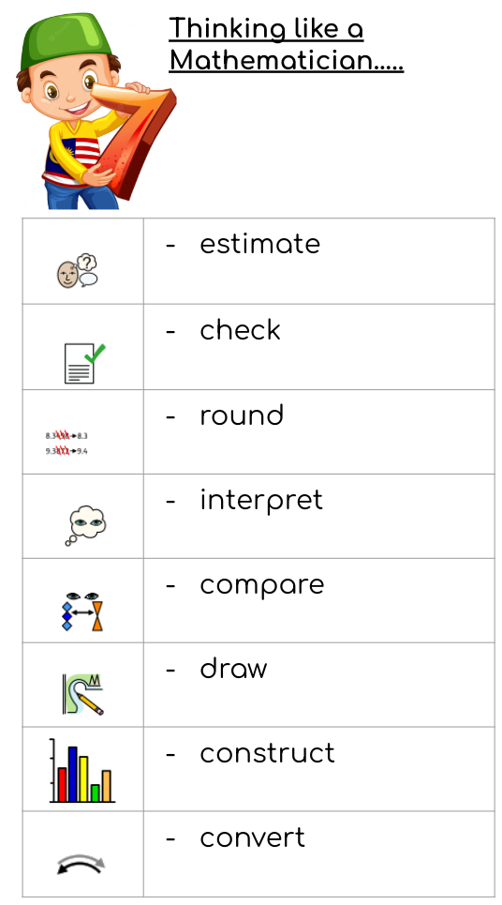

Number - number and place value
- read, write, order and compare numbers up to 10 000 000 and determine the value of each digit
- round any whole number to a required degree of accuracy
- use negative numbers in context, and calculate intervals across zero
- solve number and practical problems that involve all of the above.

Number - addition and subtraction and multiplication and division
- multiply multi-digit numbers up to 4 digits by a two-digit whole number using the formal written method of long multiplication
- divide numbers up to 4 digits by a two-digit whole number using the formal written method of long division, and interpret remainders as whole number remainders, fractions, or by rounding, as appropriate for the context
- divide numbers up to 4 digits by a two-digit number using the formal written method of short division where appropriate, interpreting remainders according to the context
- perform mental calculations, including with mixed operations and large numbers
- identify common factors, common multiples and prime numbers
- use their knowledge of the order of operations to carry out calculations involving the four operations
- solve addition and subtraction multi-step problems in contexts, deciding which operations and methods to use and why
- solve problems involving addition, subtraction, multiplication and division
- use estimation to check answers to calculations and determine, in the context of a problem, an appropriate degree of accuracy

Number - fractions
- use common factors to simplify fractions; use common multiples to express fractions in the same denomination
- compare and order fractions, including fractions > 1
- add and subtract fractions with different denominators and mixed numbers, using the concept of equivalent fractions
- multiply simple pairs of proper fractions, writing the answer in its simplest form [for example, 1/4 × 1/2 = 1/8 ] divide proper fractions by whole numbers [for example, 1/3 ÷ 2 = 1/6 ]
- associate a fraction with division and calculate decimal fraction equivalents [for example, 0.375] for a simple fraction [for example, 3/8 ]
- identify the value of each digit in numbers given to three decimal places and multiply and divide numbers by 10, 100 and 1000 giving answers up to three decimal places
- multiply one-digit numbers with up to two decimal places by whole numbers
- use written division methods in cases where the answer has up to two decimal places
- solve problems which require answers to be rounded to specified degrees of accuracy
- recall and use equivalences between simple fractions, decimals and percentages, including in different contexts.

Measurement
- solve problems involving the calculation and conversion of units of measure, using decimal notation up to three decimal places where appropriate
- use, read, write and convert between standard units, converting measurements of length, mass, volume and time from a smaller unit of measure to a larger unit, and vice versa, using decimal notation to up to three decimal places
- convert between miles and kilometres
- recognise that shapes with the same areas can have different perimeters and vice versa
- recognise when it is possible to use formulae for area and volume of shapes
- calculate the area of parallelograms and triangles
- calculate, estimate and compare volume of cubes and cuboids using standard units, including cubic centimetres (cm3 ) and cubic metres (m3 ), and extending to other units [for example, mm3 and km3 ].

Geometry - properties of shapes
- draw 2-D shapes using given dimensions and angles
- recognise, describe and build simple 3-D shapes, including making nets
- compare and classify geometric shapes based on their properties and sizes and find unknown angles in any triangles, quadrilaterals, and regular polygons
- illustrate and name parts of circles, including radius, diameter and circumference and know that the diameter is twice the radius
- recognise angles where they meet at a point, are on a straight line, or are vertically opposite, and find missing angles.

Geometry - position and direction
- describe positions on the full coordinate grid (all four quadrants)
- draw and translate simple shapes on the coordinate plane, and reflect them in the axes.
Science
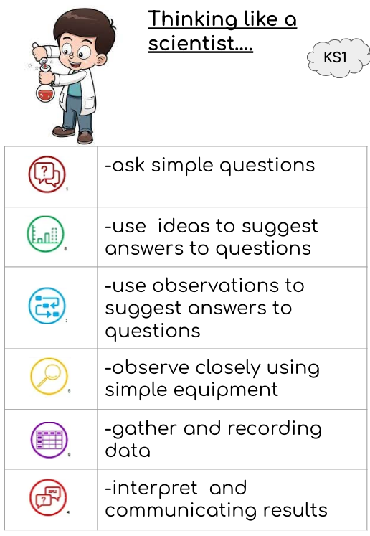
Unit |   North star questions
Light | What is light and how does it travel?  How do we see light?  Where do different colours come from?  What is reflection and how can we use it?  What are the uses of different mirrors?  What is refraction and how can we use it?  What factors affect the size, shape or type of shadow?  What are some uses of light?  Who invented the concept of ‘cats eyes’?
Electricity | What are the different components in an electrical circuit?  How will the circuit work?  What happens in a circuit when we change the components?  What is the difference between a series and parallel circuit?  Children design an electrical game.
Evolution and inheritance | What are fossils and how are they formed?  What is the theory of evolution?  Which organisms lived during each era of time?  How do animals survive in changing habitats during winter?  How do animals survive during summer?  What are traits?  How do we know traits are inherited?  How are offspring similar and dissimilar to their parents?
Animals including humans | What are the main parts of the human circulatory system?  What is pulse rate and what are the factors that affect it?  Does the resting pulse rate change with age?  Do boys/men have a different pulse rate than women/ girls?  What is the impact of diet, exercise, drugs and lifestyle on the way the human body functions?  How are water and nutrients transported within humans?
Living things and their habitats | What are the main animal groups and what are their main features?  How can invertebrates be classified?  How are plants classified?  What is bacteria?  What is fungi?
Information Communication Technology (ICT)
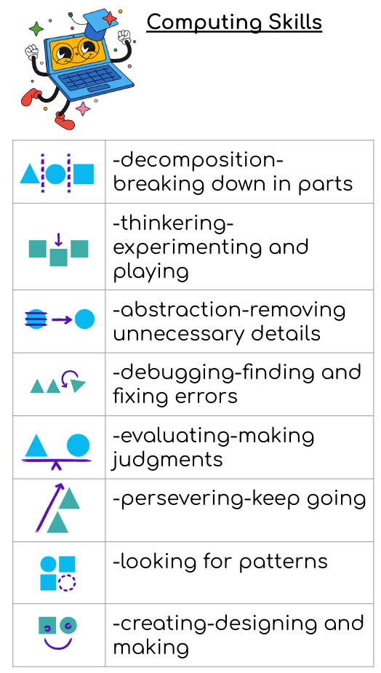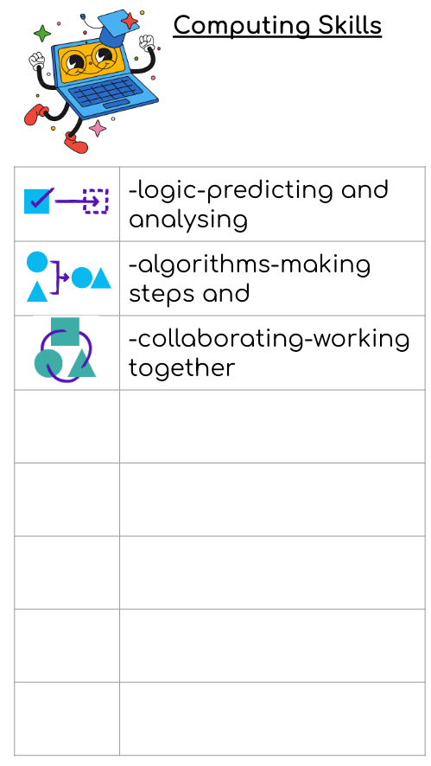
Unit | North star questions
Coding | How to design a playable game with a timer and a score?  How does the launch command work?  Why are functions useful?  How are functions created and called?  How are flow charts tested and debugged?  What are the different options of generating the user input in 2Code?  How can 2Code be used to make a text based adventure game?
Online safety | What are the benefits and risks of mobile devices?  What are the benefits and risks of giving personal information and device access to different software?  What is the meaning of a digital footprint?  Why do people use their information to create a virtual image of themselves?  What is appropriate online behaviour?  How do you protect yourself from inappropriate online behaviour?  How can online information be dangerous?  Why is it important to balance game and screen time with other parts of your life?  How does playing games online affect your health?  What are the positive and negative influences of technology on health and the environment?
Spreadsheets | What is the probability of throwing many dice?  How to use a spreadsheet to calculate the final prices in a sale?  How are formulas created to work out the prices of items?  How to use a spreadsheet to plan and how to spend pocket money?
Blogging | What is the purpose of writing a blog?  What are the features of successful blog writing?  How is the theme and content for a blog planned?  How is a blog written and posted?
Text adventures | What is a text-based adventure game?  What is the given code for a text adventure game?  How is a text adventure game debugged?
Networks | What do you know about the internet?  What is LAN?  What is WAN?  How is the internet accessed at school?  What is the age of the internet?  How might we use the internet for research in the future?
Quizzing | How do you create a picture-based quiz for young children?  How do you use the question types within 2Quiz?  What are grammar quizzes?  How do you create a quiz for teachers and parents?
Understanding Binary | How are whole numbers used to represent data in digital systems?  What do digital systems represent?  What does binary represent?  How can the numbers 0,1,2 and 3 be represented by the patterns of 2 binary digits?  How are whole numbers represented in binary?  How can division by 2 be used as a technique to determine the binary representation of any whole number?  How is the state of an object represented in a game using respective binary values?
Spreadsheets with Microsoft Excel | What does a spreadsheet look like?  How to navigate and enter data into cells?  What are the basic data formulae in Excel?  How can the use of Excel save time and effort when performing calculations?  How is a spreadsheet used to model a situation?  How can Excel make complex data clear by manipulating the way it is presented?  How is formulae for percentages, averages, max and min in spreadsheets used?  How are graphs created in Excel?  How are spreadsheets used to model a real-life situation?  How can spreadsheet skills be applied to solving problems?
Spreadsheets with Google Sheets | What does a spreadsheet look like?  How to navigate and enter data into cells?  What are the basic data formulae in Excel?  How can the use of Excel save time and effort when performing calculations?  How is a spreadsheet used to model a situation?  How can Excel make complex data clear by manipulating the way it is presented?  How is formulae for percentages, averages, max and min in spreadsheets used?  How are graphs created in Excel?  How are spreadsheets used to model a real-life situation?  How can spreadsheet skills be applied to solving problems?
History
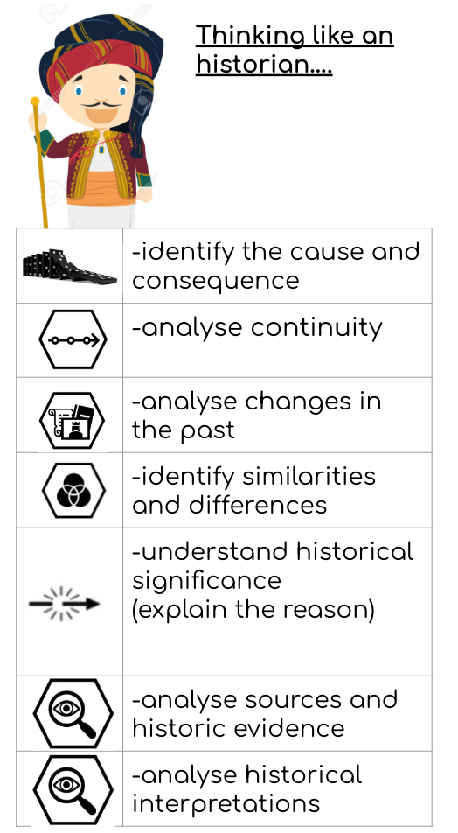
Unit | North star questions
World War 2 | What was the impact of World War 2 on the people of Britain?  Who won the battle of Britain?  What do sources tell us about the Blitz?  What was evacuation like for children?  What impact did World War 2 have on women’s lives?  How did migrants help the war effort?
The Census | What does the Census tell us about our local area?  What happened to Mary Bucktrout?  How did Mary Bucktrout feel about the events in her life?  Who lived in our local area?
Unheard histories: Who should feature on the £10.00 banknote? | Who features on banknotes and why?  Was Alfred the Great or Elizabeth I the more significant monarch?  How were Ellen Wilkinson and Betty Boothroyd historically significant?  Why was William Tuke significant?  Who was more significant? Lilly Parr or Betty Snowball?  Who will be the face of the new £10 note?
Geography
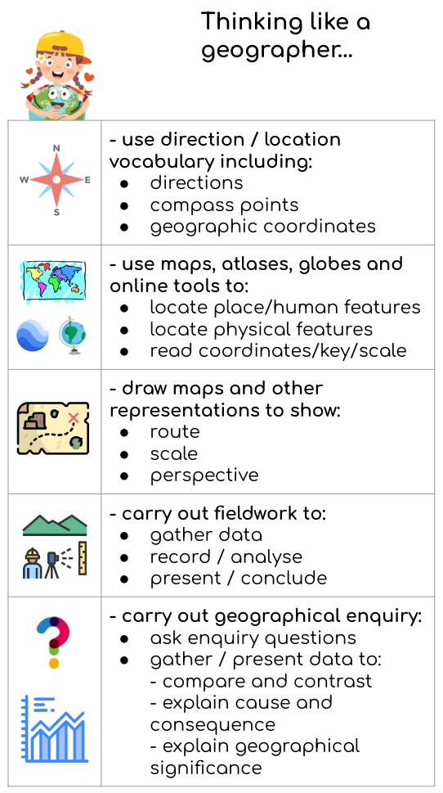
Unit | North star questions
Population | Where are all the people?  Why does the population change?  What is the population pyramid?  What challenges can an aging population present?  What challenges can a growing population present?  What challenges do people face living in slums?  How can we make sure there is enough food for everyone on Earth?  How is the population distributed in the UK?
Globalisation | What is globalisation?  How has globalisation changed the way we communicate?  How does globalisation affect trade?  What does globalisation have to do with fashion?  Where were your clothes made?  What does globalisation have to do with food?  Where does our food come from?  Where will globalisation lead us?  How globalised is your life?  What impact has globalisation had on your life?
Physical Social Health Education (PSHE)
Unit | North star questions
Being me in my world | I can identify my goals for this year, understand my fears and worries about the future and know how to express them  I know how to use my Jigsaw Journal  I know that there are universal rights for all children but for many children these rights are not met  I understand that my actions affect other people locally and globally  I can make choices about my own behaviour because I understand how rewards and consequences feel and  I understand how these relate to my rights and responsibilities  I understand how an individual’s behaviour can impact on a group  I understand how democracy and having a voice benefits the school community
Celebrating differences | I understand there are different perceptions about what normal means  I understand how being different could affect someone’s life  I can explain some of the ways in which one person or a group can have power over another  I know some of the reasons why people use bullying behaviours  I can give examples of people with disabilities who lead amazing lives  I can explain ways in which difference can be a source of conflict and a cause for celebration
Dreams and goals | I know my learning strengths and can set challenging but realistic goals for myself  I can work out the learning steps I need to take to reach my goal and understand how to motivate myself to work on these  I can identify problems in the world that concern me and talk to other people about them  I can work with other people to help make the world a better place  I can describe some ways in which I can work with other people to help make the world a better place  I know what some people in my class like or admire about me and can accept their praise
Healthy me | I can take responsibility for my health and make choices that benefit my health and well-being  I know about different types of drugs and their uses and their effects on the body particularly the liver and heart  I understand that some people can be exploited and made to do things that are against the law  I know why some people join gangs and the risks this involves  I understand what it means to be emotionally well and can explore people’s attitudes towards mental health/illness  I can recognise stress and the triggers that cause this and I understand how stress can cause drug and alcohol misuse
Relationships | I know that it is important to take care of my mental health  I know how to take care of my mental health  I understand that there are different stages of grief and that there are different types of loss that cause people to grieve  I can recognise when people are trying to gain power or control  I can judge whether something online is safe and helpful for me  I can use technology positively and safely to communicate with my friends and family
Changing me | I am aware of my own self-image and how my body image fits into that  I can explain how girls’ and boys’ bodies change during puberty and understand the importance of looking after yourself physically and emotionally  I can describe how a baby develops from conception through the nine months of pregnancy, and how it is born  I understand how being physically attracted to someone changes the nature of the relationship and what that might mean about having a girlfriend/ boyfriend  I know myself well enough to maintain positive relationships with others whilst still keeping my own identity  I am aware of the importance of a positive self-esteem and what I can do to develop it  I can identify what I am looking forward to and what worries me about the transition to secondary school /or moving to my next class.
Religious Education (RE)
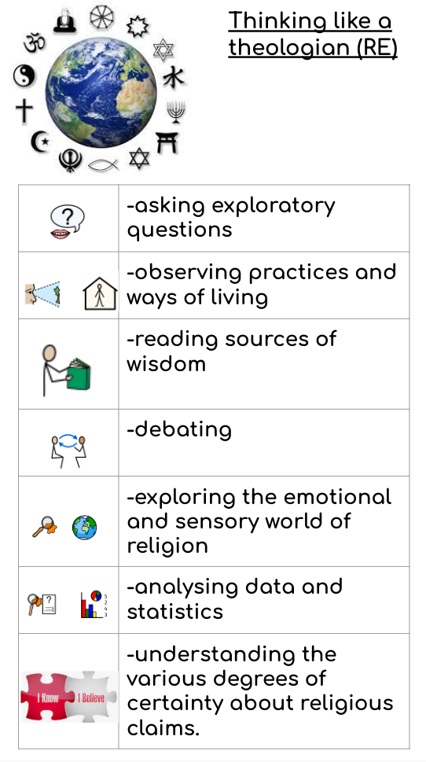
Unit | North star questions
Inspirational people | - Can I explore Muhammad Ali’s life story?  - What can we learn from Muhammad Ali’s example?  - Who is Barack Obama?  - Why was Barack Obama such a significant leader?  - Significant female leaders: Michelle Obama  - Who is Mahatma Gandhi?  - What can we learn from Mahatma Gandhi’s life?  - What were Mahatma Gandhi's religious influences?  - What was Malala Yousafzai's life journey?  - Malala: Turning hardship into positive change  - Gender equality in education: Malala’s legacy  - What are the similarities and differences between Malala and other influential people?  - Presenting and discussing an inspirational figure
Beliefs in action | - Beliefs in action: What do we know about Judaism?  - Beliefs in action: What do we know about Christianity?  - Beliefs in action: What do we know about Islam?  - Beliefs in action: What do we know about Sikhism?  - Beliefs in action: What do we know about Hinduism?  - Beliefs in action: What do we know about Buddhism?  - What is my worldview and why does it matter?  - Beliefs in action: Equality vs Equity  - Beliefs in action: What is justice?  - Beliefs in action: Social justice and human rights  - Beliefs in action: Social justice and oppression  - Beliefs in action: How can I create positive change?
Physical Education
Unit | North star
Football | - To revisit dribbling techniques and explore when to use smaller or bigger touches according to the space available  - To stay on the ball whilst under pressure from an opponent and recognise how and when to escape in to space  - To use a variety of individual possession skills and tricks in order to beat a defender in various opposed situations  - To connect and combine with team mates using short passing and receiving techniques  - To make effective forward passes in order to create opportunities to score  - To attack effectively as a team by keeping possession of the ball using a combination of both short and longer passes  - To apply attacking principles in a game scenario in order to create goal scoring opportunities
Netball | - Revisit and develop passing techniques and apply them in opposed situations  - Develop movement and support play in order to attack effectively  - To further develop pivoting techniques and apply them in opposed games  - To develop an understanding of attacking play and attacking principles  - To explore advanced shooting techniques such as step-back shot and side-step shot and apply them in opposed games  - To apply a range of techniques learned and apply them in constrained and full High 5 netball matches
Hockey | - To recap dribbling in hockey using the Indian Dribble technique  - To eliminate an opponent in a 1v1 situation using a trick/skill move using the ‘forehand drag’  - Develop tackling an opponent safely in order to regain possession  - To develop medium and long-range passing and receiving skills and apply them in a game situation  - To develop and apply various shooting techniques whilst under pressure from an opponent  - To create and exploit space in order to support attacking play in small sided games
Tennis | - To perform a range of different shots and strategies to outwit an opponent  - To develop advanced tennis specific movement, footwork and reaction speed  - To explore different ways of playing the forehand shot to win a point  - To develop different ways of playing the two-handed backhand drive including cross court and down the line  - To understand the five different ways to win a point in tennis  - To carry out the role of an umpire
Athletics | - To sprint over and between obstacles using consistent stride lengths  - To develop coordination and rhythm when sprinting over hurdles  - To demonstrate a dynamic sling throw  - To perform a triple jump combination with balance and control  - To develop the dynamic heave throw (hammer throw) technique  - Sustain running at a consistent pace over a medium distance  - Develop the one-handed pull throw technique in a competition  - To pass a relay baton at speed developing the push pass  - Apply running, jumping and throwing techniques in competition  - Record and measure performance of self and others  - Describe the basic techniques which make for good performance
Rounders | - To develop fast reactions required for catching balls thrown at different heights, speeds and angles  - To strike a bowled ball with power in to space in the deep field  - To develop game understanding of fielding and team play in a variety of fielding positions  - To develop throwing from deep in the field with power and accuracy over a long distance  - To further develop an understanding of the role of the umpire in rounders and to assess the performance of an umpire  - To play cooperatively with teammates; applying a range of tactics and strategies when batting, bowling and fielding
Art and Design
Unit | North star
Make my voice heard | What are expressive drawing techniques?  How can symbolism in art convey meaning?  How can I use the drawing technique, chiaroscuro?  What is the context and intention of street art?  How can I use impact and effect to create a powerful image?
Artist study | How do I analyse a painting?  How can I find meaning in painting?  How can drama techniques help me explore the meaning of a painting?  How can interpretation skills be used to analyse and respond to an abstract painting?  How can art tell stories or portray messages?  What are the starting points for creative outcomes?  What painting techniques will I choose to use?
Making memories | How can art explore the concept of self?  What sculptural techniques are there?  How can I use creative experiences to develop ideas and plan a sculpture?  What materials and techniques can I use to work in 3D?  How can I problem solve, evaluate and refine artwork to achieve a chosen outcome?
Photo opportunity | How can I use composition to create an effective photomontage advertising poster?  How can I use understanding of abstract art in photography?  What design choices can I make using digital photography techniques?  How can I use photography to design and recreate a famous painting?  How can I use observation and proportion to create art in a photorealistic style?
Design and Technology (D&T)
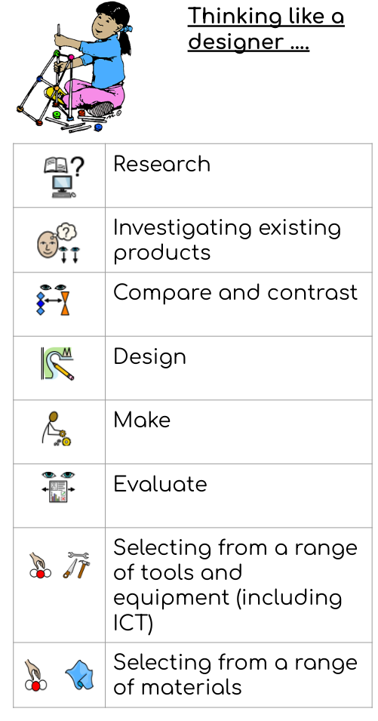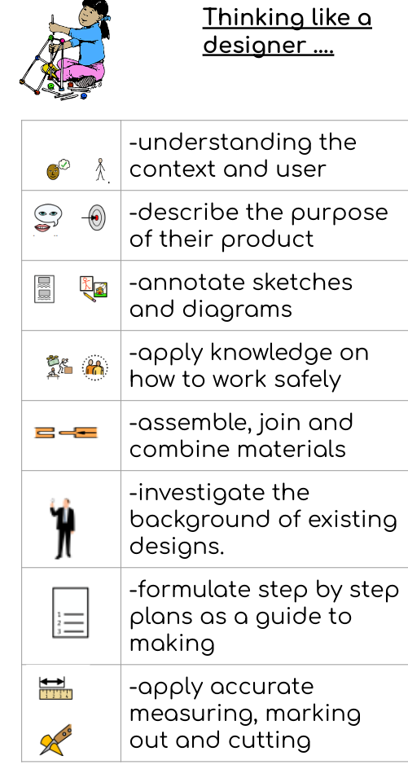
Unit | North star
Textiles: waistcoats | What will my waistcoat look like?  How can I mark and cut fabric effectively?  How can I assemble my waistcoat?  How can I add decoration to my waistcoat?
Structure: playgrounds | What structures would be best for a playground?  How can I build different structures?  How can I improve and add detail to my structure?  What will the surrounding landscape look like?
Digital world: Navigating the world | How can I write a design brief and criteria to meet a client’s request?  How can a program include multiple functions as part of a navigation design?  How can I consider sustainability when developing a product?  How can 3D CAD be used to produce a virtual model?  How can I pitch my product to a specified client?
Musical Education
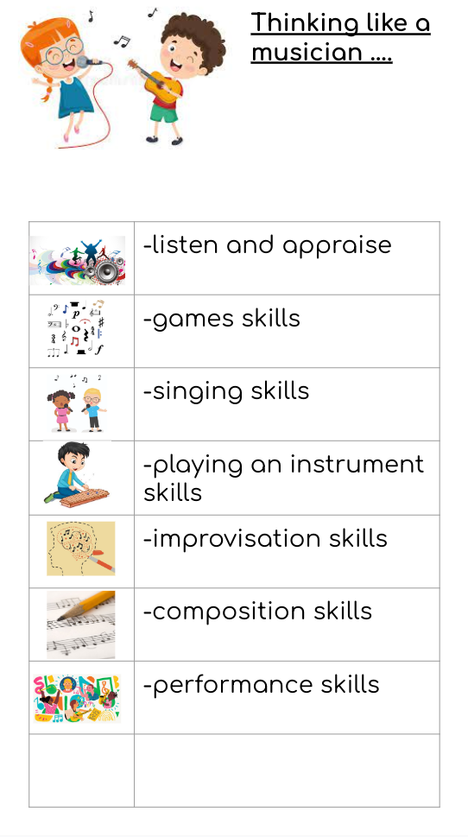
Unit | Skills | Knowledge
Musicianship (including general musicianship and notation) Understanding Music | Listening Finding and keeping a steady beat Copy-back Improvisation Singing Playing instruments Reading notation  Pulse/beat Rhythm Pitch Tempo Dynamics | To use body percussion, instruments and voices.  The key centres of C major, G major, D major, A minor and D minor.  The time signatures of 2/4, 3/4, 4/4, 5/4 and 6/8.  To find and keep a steady beat.  To listen and copy rhythmic patterns made of minims, dotted crotchets, crotchets, dotted quavers, triplet quavers, quavers, semiquavers and their rests, by ear or from notation.
Listen and Respond | Listening Responding Musical styles Historical context Different musicians Connecting  Pulse Rhythm Pitch Tempo Dynamics Timbre Texture Structure | To talk about feelings created by the music.  To justify a personal opinion with reference to the musical elements.  To identify 2/4, 4/4, 3/4, 6/8 and 5/4.  To identify the musical style of a song, using some musical vocabulary to discuss its musical elements.  To identify the following instruments by ear and through a range of media: bass guitar, electric guitar, percussion, sections of the orchestra such as brass, woodwind and strings, electric organ, congas, pianos and synthesisers, and vocal techniques such as scat singing.  To discuss the structure of the music with reference to verse, chorus, bridge and an instrumental break.  To explain a bridge passage and its position in a song.  To recall (by ear) memorable phrases heard in the music.  To identify major and minor tonalities, chord triads I, IV and V, and intervals within a major scale.  To explain the role of a main theme in a musical structure.  To understand what a musical introduction and outro are, and their purposes.  To identify the sound of a Gospel choir and soloist, a Rock band, a symphony orchestra and an A cappella group.  To recognise the following styles and any key musical features that distinguish them: 20th and 21st Century Orchestral; Soul; Pop; Hip Hop; Jazz: Swing; Rock; Disco; Romantic; Zimbabwean Pop; RnB; Folk; Gospel; Salsa; Reggae; Musicals and Film Music.
Learn to Sing the Song | Singing Listening Notation  Pulse Rhythm Pitch Tempo Dynamics Structure | To rehearse and learn songs from memory and/or with notation.  To sing a broad range of songs as part of a choir, including those that involve syncopated rhythms, with a good sense of ensemble and performance. This should include observing rhythm, phrasing, accurate pitching and appropriate style.  Continue to sing in parts where appropriate.  To sing in 2/4, 4/4, 3/4, 5/4 and 6/8.  To sing with and without an accompaniment.  To sing syncopated melodic patterns.  To demonstrate and maintain good posture and breath control whilst singing.  To lead a singing rehearsal.  To talk about the different styles of singing used in the different songs sung throughout this year.  To discuss with others how connected they are to the music/songs, and how the songs and styles are connected to the world.
Play Your Instruments with the Song | Playing instruments Keeping a steady beat Playing in a group/ensemble Notation  Pulse Rhythm Pitch Tempo Dynamics Timbre Texture Structure | To rehearse and learn to play one of four differentiated instrumental parts, by ear or from notation, in the tonal centres of C major, F major, G major, D major, E major, A major, E♭ major, D minor and F minor.  To play a melody, following staff notation written on one stave and using notes within an octave range (do–do); to make decisions about dynamic range, including very loud (fortissimo), very quiet (pianissimo), moderately loud (mezzo forte) and moderately quiet (mezzo piano).  To play a part on a tuned instrument, by ear or from notation:  ● Playing the right notes with secure rhythms.  ● Rehearsing and performing their parts within the context of the unit song.  ● Playing together with everybody while keeping the beat.  ● Listening to and following musical instructions from a leader.  ● Treating instruments carefully and with respect.  ● Playing their instruments with good posture.  ● Understanding how to rehearse a piece of music in order to improve.  ● Playing a more complex part.
Improvise with the Song | Improvising Listening  Pulse Rhythm Pitch Tempo Dynamics Structure | To explore improvisation within a major scale, using the notes: C, D, E, F, G G, A, B♭, C, D G, A, B, C, D F, G, A, C, D  To improvise over a groove, responding to the beat and creating a satisfying melodic shape with varied dynamics and articulation.  To follow a steady beat and stay ‘in time’.  To become more skilled in improvising; perhaps trying more notes and rhythms. To include rests or silent beats. To think about creating music with ‘phrases’ made up of notes, rather than just lots of notes played one after the other.
Compose with the Song | Composing Notation  Pulse Rhythm Pitch Tempo Dynamics Notation | To plan and compose an eight or 16-beat melodic phrase using the pentatonic scale (eg C, D, E, G, A) and incorporate rhythmic variety and interest. To play this melody on available tuned percussion and/or orchestral instruments. To notate this melody.  Either of these melodies can be enhanced with rhythmic or simple chordal accompaniment. To create a simple chord progression.  To compose a ternary (ABA form) piece; to use available music software/apps to create and record it, discussing how musical contrasts are achieved.  To use music technology, if available, to capture, change and combine sounds.  To create music in response to music and video stimuli.  Start to use structures within compositions, eg introductions, multiple verse and chorus sections, AB form or ABA form (ternary form).  To use rhythmic variety.  To compose song accompaniments, perhaps using basic chords.  To use a wider range of dynamics, including fortissimo (very loud), pianissimo (very quiet), mezzo forte (moderately loud) and mezzo piano (moderately quiet).  To use full scales in different keys.  To create a melody using crotchets, quavers, minims, perhaps semibreves and semiquavers, and all equivalent rests.  To use a pentatonic and a full scale as well as major and minor tonalities.  To understand the structure of the composition.  To explain a composition’s musical shape, identifying melodic intervals (a melody that leaps) and melodic steps (a melody that moves to the next note).  To include a home note, providing a sense of an ending; coming home.  To perform their simple composition/s using their own choice of notes.  To successfully create a melody in keeping with the style of the backing track and to describe how their melodies were created.  To create their composition/s with an awareness of the basic/simple chords in the backing track.
Music Notepad |  | To compose a ‘stand-alone’ piece of music which includes:  ● A time signature.  ● A treble clef.  ● Four, six, eight or 12 bars.  ● The right notes for the scale and key signature.  ● Rhythmic combinations of semibreves, minims, crotchets, paired quavers, semiquavers and their rests.  ● Expression/dynamics.  ● Structured musical ideas (eg using echo or question-and-answer phrases) to create music that has a beginning, middle and end.  ● A melody that starts and ends on note one.
Perform the Song | Performing Listening Playing Singing Improvising Composing Notation  Pulse Rhythm Pitch Tempo Dynamics Timbre Texture Structure | To create, rehearse and present a holistic performance for a specific event, for an unfamiliar audience.  To perform a range of songs as a choir in school assemblies, school performance opportunities and for a wider audience.  To create, rehearse and present a holistic performance with a detailed understanding of the musical, cultural and historical contexts.  To perform from memory or with notation.  To understand the value of choreographing any aspect of a performance. To understand the importance of a performing space and how to use it.  A student or a group of students to rehearse and lead parts of the performance.  To record the performance and compare it to a previous performance.  To collect feedback from the audience and reflect on how the audience believed in the performance.  To discuss how the performance might change if it was repeated in a larger/smaller performance space.

