English
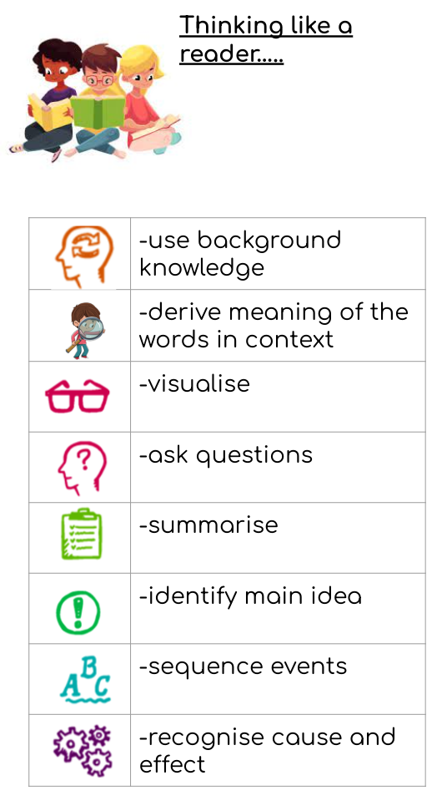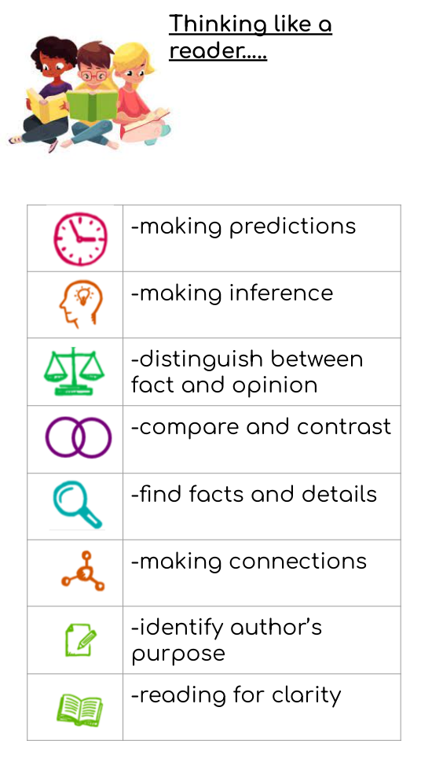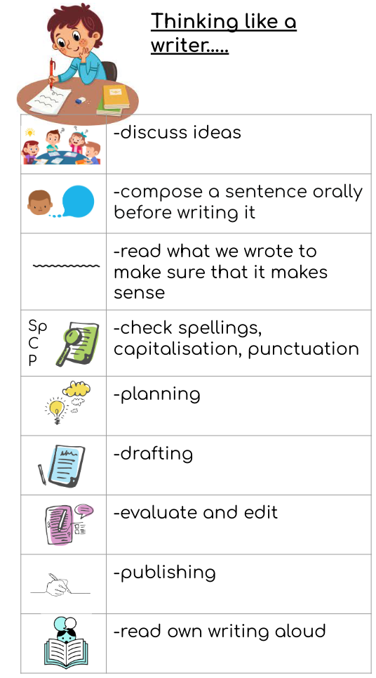

Word Reading
- apply phonic knowledge and skills as the route to decode words.
- respond speedily with the correct sound to graphemes (letters or groups of letters) for all 40+ phonemes, including, where applicable, alternative sounds for graphemes
- read accurately by blending sounds in unfamiliar words containing GPCs that have been taught
- read common exception words, noting unusual correspondences between spelling and sound and where these occur in the word
- read words containing taught GPCs and –s, –es, –ing, –ed, –er and –est endings
- read other words of more than one syllable that contain taught GPCs
- read words with contractions [for example, I’m, I’ll, we’ll], and understand that the apostrophe represents the omitted letter(s)
- read books aloud, accurately, that are consistent with their developing phonic knowledge and that do not require them to use other strategies to work out words
- reread these books to build up their fluency and confidence in word reading
Reading comprehension
- develop pleasure in reading, motivation to read, vocabulary and understanding by:

- listening to and discussing a wide range of poems, stories and non-fiction at a level beyond that at which they can read independently
- being encouraged to link what they read or hear to their own experiences
- becoming very familiar with key stories, fairy stories and traditional tales, retelling them and considering their particular characteristics
- recognising and joining in with predictable phrases
- learning to appreciate rhymes and poems, and to recite some by heart
- discussing word meanings, linking new meanings to those already known

- understand both the books they can already read accurately and fluently and those they listen to by:

- drawing on what they already know or on background information and vocabulary provided by the teacher
- checking that the text makes sense to them as they read, and correcting inaccurate reading
- discussing the significance of the title and events
- making inferences on the basis of what is being said and done
- predicting what might happen on the basis of what has been read so far
- participate in discussion about what is read to them, taking turns and listening to what others say
- explain clearly their understanding of what is read to them
Writing transcription
- words containing each of the 40+ phonemes already taught
- common exception words
- the days of the week
- name the letters of the alphabet:
- naming the letters of the alphabet in order
- using letter names to distinguish between alternative spellings of the same sound

- add prefixes and suffixes:
- using the spelling rule for adding –s or –es as the plural marker for nouns and the third person singular marker for verbs
- using the prefix un–
- using –ing, –ed, –er and –est where no change is needed in the spelling of root words [for example, helping, helped, helper, eating, quicker, quickest]
- apply simple spelling rules and guidance, as listed in English appendix 1
- write from memory simple sentences dictated by the teacher that include words using the GPCs and common exception words taught so far
Handwriting
- sit correctly at a table, holding a pencil comfortably and correctly
- begin to form lower-case letters in the correct direction, starting and finishing in the right place
- form capital letters
- form digits 0-9
- understand which letters belong to which handwriting ‘families’ (ie letters that are formed in similar ways) and to practise these
Writing composition
- write sentences by:
- saying out loud what they are going to write about
- composing a sentence orally before writing it
- sequencing sentences to form short narratives
- re-reading what they have written to check that it makes sense
- discuss what they have written with the teacher or other pupils
Writing - vocabulary, grammar and punctuation
- develop their understanding of the concepts set out in English appendix 2 by:
- leaving spaces between words
- joining words and joining clauses using ‘and’
- beginning to punctuate sentences using a capital letter and a full stop, question mark or exclamation mark
- using a capital letter for names of people, places, the days of the week, and the personal pronoun ‘I’
- learning the grammar for year 1 in English appendix 2
- use the grammatical terminology in English English appendix 2 in discussing their writing

Mathematics
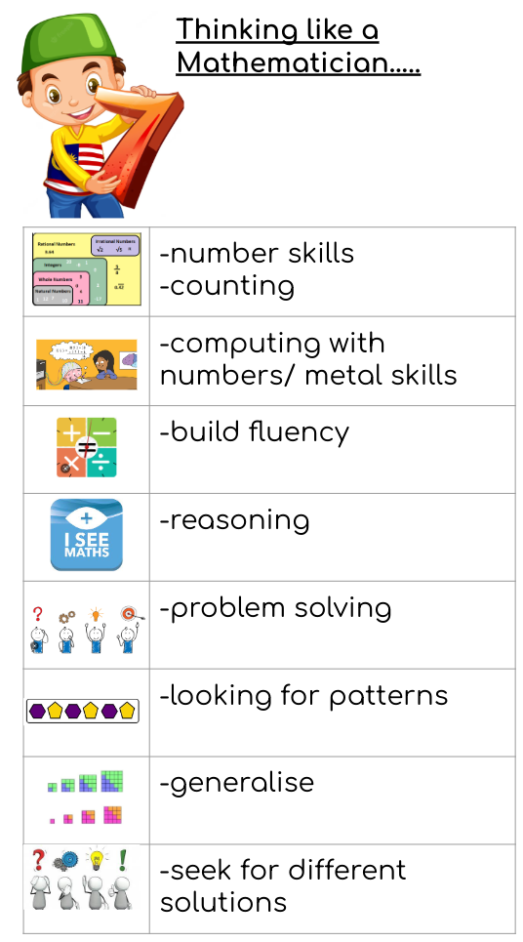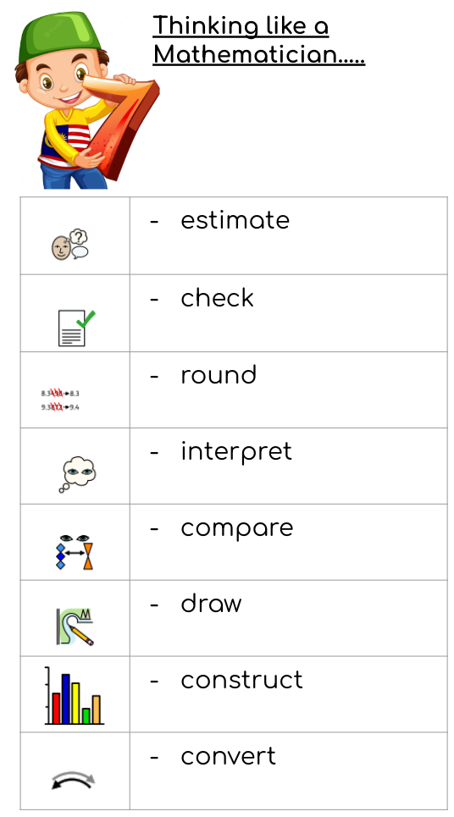

Number - number and place value
- count to and across 100, forwards and backwards, beginning with 0 or 1, or from any given number
- count, read and write numbers to 100 in numerals; count in multiples of 2s, 5s and 10s
- given a number, identify 1 more and 1 less
- identify and represent numbers using objects and pictorial representations including the number line, and use the language of: equal to, more than, less than (fewer), most, least
- read and write numbers from 1 to 20 in numerals and words

Number - addition and subtraction
- read, write and interpret mathematical statements involving addition (+), subtraction (−) and equals (=) signs
- represent and use number bonds and related subtraction facts within 20
- add and subtract one-digit and two-digit numbers to 20, including 0
- solve one-step problems that involve addition and subtraction, using concrete objects and pictorial representations, and missing number problems such as 7 = ? − 9

Number - multiplication and division
- solve one-step problems involving multiplication and division, by calculating the answer using concrete objects, pictorial representations and arrays with the support of the teacher

Number - fractions
- recognise, find and name a half as 1 of 2 equal parts of an object, shape or quantity
- recognise, find and name a quarter as 1 of 4 equal parts of an object, shape or quantity

Measurement
- compare, describe and solve practical problems for:
    - lengths and heights [for example, long/short, longer/shorter, tall/short, double/half]
    - mass/weight [for example, heavy/light, heavier than, lighter than]
    - capacity and volume [for example, full/empty, more than, less than, half, half full, quarter]
    - time [for example, quicker, slower, earlier, later]
- measure and begin to record the following:
    - lengths and heights
    - mass/weight
    - capacity and volume
    - time (hours, minutes, seconds)
    - recognise and know the value of different denominations of coins and notes
    - sequence events in chronological order using language [for example, before and after, next, first, today, yesterday, tomorrow, morning, afternoon and evening]
- recognise and use language relating to dates, including days of the week, weeks, months and years
- tell the time to the hour and half past the hour and draw the hands on a clock face to show these times

Geometry - properties of shapes
- recognise and name common 2-D and 3-D shapes, including:
    - 2-D shapes [for example, rectangles (including squares), circles and triangles]
    - 3-D shapes [for example, cuboids (including cubes), pyramids and spheres]

Geometry - position and direction
- describe position, direction and movement, including whole, half, quarter and three-quarter turns

Science
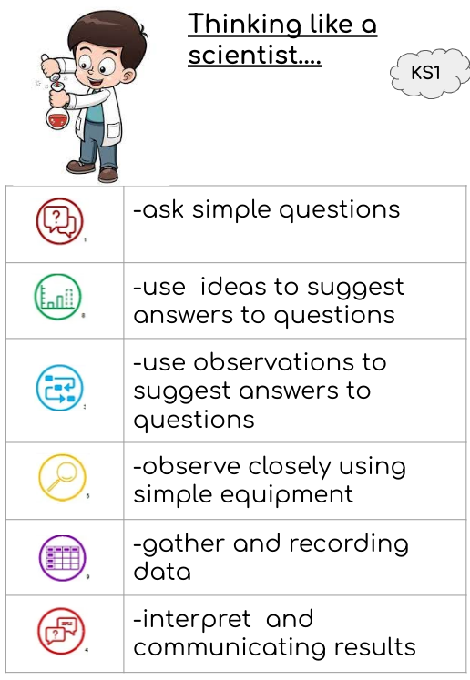
Unit |   North star questions
Seasons | - What are the four seasons?  - How do seasons change?  - How does the weather change each season?  - How does the day length vary?  - Why is it not safe to look directly at the Sun?
Animals including humans - The human body | - What is the name of the parts of the human body?  - What body part is associated with sight and smell?  - What body part is associated with touch, taste, hearing?  - How does height impact the length of hand spans?  - How does height impact foot size ?
Animals including humans - Animals | - Which groups do different animals belong to?  - Which animals are carnivores, herbivores and omnivores?  - How can we sort a variety of common animals?  - What do different animals eat?  - Which animals are kept as pets?
Everyday materials | - What is a material?  - Which material is best for different objects?  - How can objects be described?  - How can you group and compare materials?  - What is the best material for an umbrella?  - What is the best material for curtains?  - What is the best material for a bookshelf?
Plants | - How is our flower growing?  - How is our vegetable growing?  - What types of plants grow in the wild?  - What types of plants grow in the garden?  - What are the parts of trees called?  - What is the difference between deciduous and evergreen trees?  - What is the basic structure of a flowering plant?  - What are the common names of flowers?  - What is the same and what is different about the flowers and vegetables we planted?
Information Communication Technology (ICT)
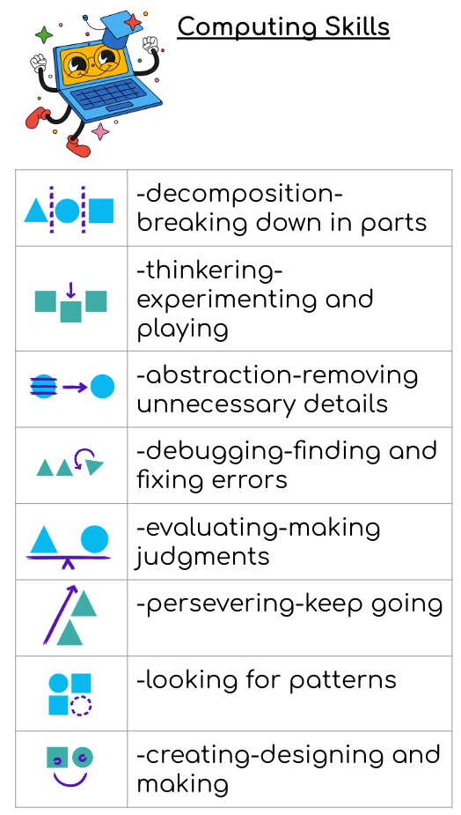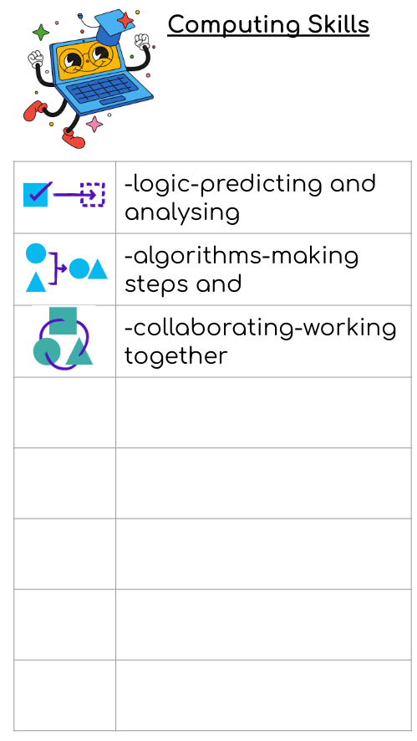
Unit | North star questions
Online safety and exploring purple mash | - How do we keep personal information safe?  - How to find saved work on the online area?  - How to add pictures and text to work?  - What are the different Purple Mash tools?
Grouping and Sorting | - How do we sort items using a range of criteria?  - What does the term algorithm mean?
Pictograms | - How is data represented?  - What does a pictogram show?  - How is a pictogram used to record the results of an experiment?
Lego builders | - Why is it important to follow instructions?  - How to follow and create instructions on a computer?  - How does the order of instructions affect the results?
Maze explorers | - How are direction keys used to complete challenges?  - How to create and debug a set of instructions?  - How is an algorithm list extended?
Animated story books | - What are the differences between traditional and e-books?  - How to save additional changes and overwrite files?  - How is sound added to a picture?  - How to add a background to the story?
Coding | What are instructions?  What are objects and actions?  What is an event?  How is an event used to control an object?  How is the scale property used?  How is a computer program planned and made?
Spreadsheets | What does a spreadsheet look like?  How are images added to spreadsheets?  How are items calculated?
Technology outside school | What is technology?  Where is technology used in the local community?
History
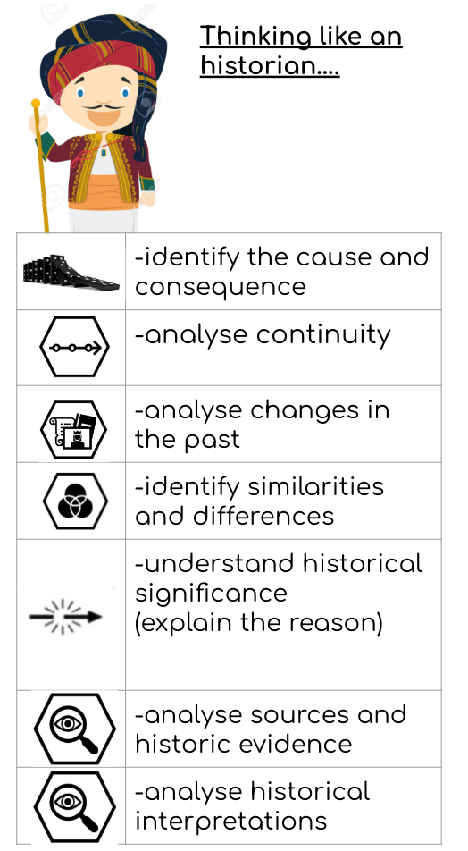
Unit | North star questions
How am I making history? | - What is my history?  - How can I find out more about myself?  - How are special events remembered?  - What was it like for children in the past?  - What have I learnt about childhood in the past?
How have toys changed? | - What is your favourite toy?  - Did your parents and grandparents play with the same toys as you?  - What were toys like in the past?  - What is similar and different about toys now and in the past?  - How have teddy bears changed over time?
How have explorers changed the world? | - What is an explorer?  - Where have explorers travelled and when?  - Who was Christopher Collumbus and what did he do?  - Who was Matthew Henson and what did he do?  - How has exploration changed?  - How can we remember explorers?
Geography
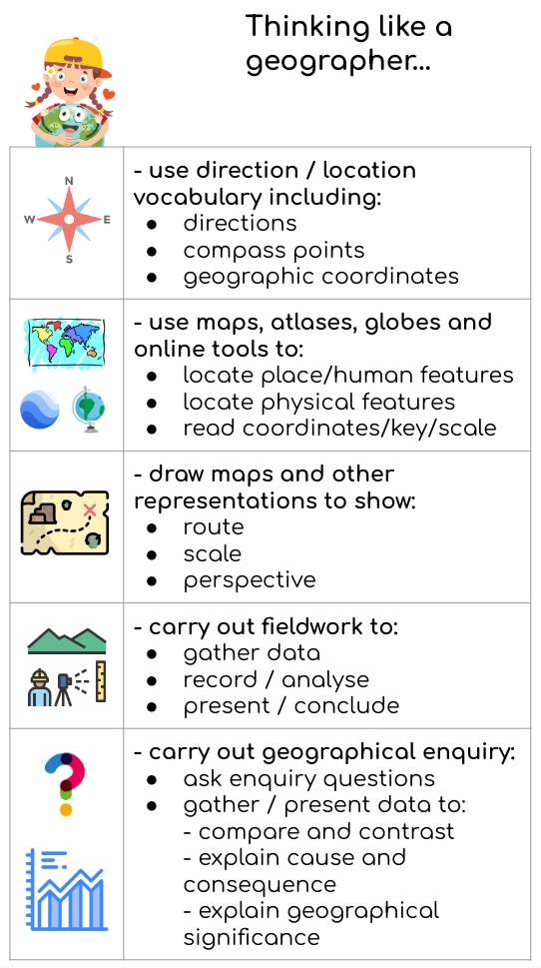
Unit | North star questions
London in the United Kingdom | - What is the United Kingdom?  - What can you find in the United Kingdom?  - What is the history of London?  - How do people move around in London?  - What are the landmarks in London?  - What is the weather?  - What is the weather like in the United Kingdom?
Seven Continents | - What is a continent?  - What is Europe like?  - What is Australia like?  - What is Africa like?  - What is Asia like?  - What is North America like?  - What is South America like?  - What is Antarctica like?  - How is Alaska different from Cornwall?  - How is Alaska similar to Cornwall?
Oceans and seas | - What is an ocean?  - Where are the world’s oceans?  - How deep is the ocean?  - Why are our oceans important?  - What lives in the ocean?  - How is the ocean different at the North Pole and the Equator?  - Why are the oceans under threat?  - How are people protecting the oceans?  - How can we protect our oceans?
Physical Social Health Education (PSHE)
Unit | North star questions
Being me in my world | - How do you feel special and safe in my class?  - What are my rights and responsibilities?  - What are rewards and what makes me feel proud?  - What are consequences?
Celebrating differences | - What is bullying?  - What do I do about bullying?  - How to make new friends?  - How are differences celebrated?
Dreams and goals | - What have I already succeeded in?  - What have we achieved together?  - How are obstacles overcome?  - How is success celebrated?
Healthy me | - What does it mean to be healthy?  - What healthy choices can I make?  - How can I keep clean and healthy?  - What is medicine and how do we take it safely?  - How do we keep safe on the road?
Relationships | - Who is my family?  - How do we make friends?  - How do we greet others?  - What people help us?
Changing me | - What are life cycles?  - How has my body changed?  - How are boys and girls different?  - How do we cope with changes?
Religious Education (RE)
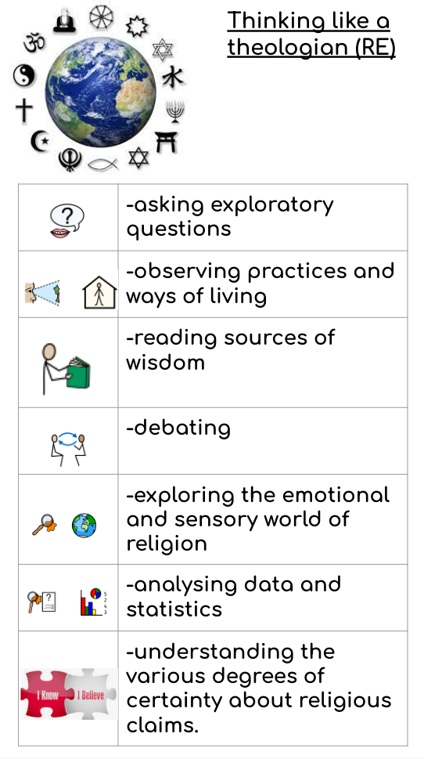
Unit | North star questions
What do Christians believe about God? | Beliefs  - What do people believe about God, humanity and the natural world?  - How do these beliefs affect the way we live our lives and care for our world?  - Why do we need rules?  - What is the difference between right and wrong behaviour?  - Why is prayer important?  - How do faith groups show their belief in God?
What gifts might Christians in my town have given Jesus if he had been born here rather than in Bethlehem? | Celebrations  - What religious festivals are celebrated?  - Why and how do we celebrate religious festivals?
Who is God to muslims? | Beliefs  - What do people believe about God,  - humanity and the natural world?  - How do these beliefs affect the way we live our lives and care for our world?  - Why do we need rules?  - What is the difference between right and wrong behaviour?  - Why is prayer important?  - How do faith groups show their belief in God?
Why was Jesus welcomed like a king or celebrity by the crowds on Palm Sunday? | Celebrations  - What religious festivals are celebrated?  - Why and how do we celebrate religious  - festivals?
How important is the Quran to muslims? | Special books  - What is their special book and why?  - What are the holy books associated with different faiths?  - Why are they important to their communities and faith groups?  - What stories do they contain?
How important is the prophet Muhammed to muslims? | Leaders and teachers  - What leaders are important in religion?  - What did they believe about God?  - How did this affect the way they lived their lives?  - What special stories are there about these religious leaders?
Physical Education
Unit | North star
(Y1) Unit 1 - Fundamental Movement Skills Through Tag Games | - To be able to move safely in a space with control  - To understand how to tag safely in a tag game  - To move safely and to avoid being tagged in a tag game  - To be able to react quickly in a tag game  - To help others escape when caught in a tag game  - To demonstrate a combination of skills learned in this unit
Exploring manipulative skills | - To be able to send a ball towards a target  - To be able to release a ball towards a moving target  - To move with a ball using our feet  - To change direction with a ball using our feet  - To dribble with a ball using our hands  - To move with a ball and keep it away from another player using our hands
Functional movement | - To walk and run using an opposite arm to leg action  - To develop an awareness of space and to remember a movement pattern  - To develop anticipation and reactions with a moving ball using hands  - To kick a ball towards a target over various distances  - To explore striking a ball with a bat or a racket  - To bend and stretch in a variety of directions and at different levels
Developing manipulatives skills | - To throw and catch a ball with a partner using two hands  - To throw and catch different objects using two hands  - To throw and catch a ball whilst I am moving  - To throw a small object using an overarm throw  - To throw a ball at a target from a close distance  - To throw and catch a ball in competitive team games
Movement concepts | - To develop jumping for height and jumping for distance  - To move in time to a rhythm  - To develop catching a ball from different directions and heights  - To develop the lunge movement for stability and balance  - To side step and hop in different directions  - To bounce and catch with a partner using a variety of balls
Athletics fundamentals | - To explore different ways of moving  - To jump over an object with two feet  - To jump for distance with two feet  - To throw an object at a target  - To explore different ways of jumping over obstacles  - To throw an object as far as possible  - To choose the best way to throw different objects  - To run over obstacles with control  - To throw a ball using a push throw
Art and Design
Unit | North star
Make your mark | - To know how to create different types of lines.  - To explore line and mark making to draw water
Colour splash | - To investigate how to mix secondary colours  - To apply knowledge of colour mixing when painting  - To explore colour when printing  - To experiment with paint mixing to make a range of secondary colours  - To apply my painting skills when working in the style of an artist
Sculpture and 3D | - To roll paper to make 3D structures  - To shape paper to make a 3D drawing  - To apply paper-shaping skills to make an imaginative sculpture  - To work collaboratively to plan and create a sculpture  - To apply painting skills when working in 3D
Woven wonders | - To know that art can be made in different ways  - To choose, measure, arrange and fix materials  - To explore plaiting, threading and knotting techniques  - To learn how to weave  - To combine techniques in a woven artwork
Design and Technology (D&T)
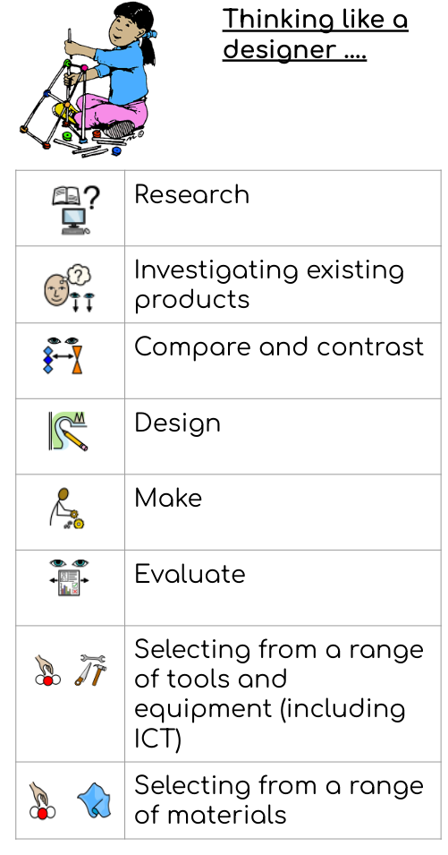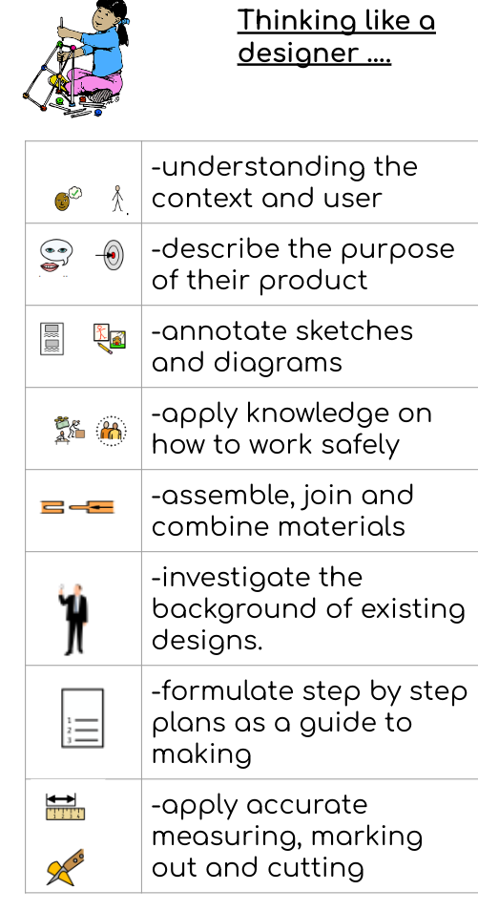
Unit | North star
Constructing a windmill | - How can I create a stable structure?  - How can I use tools and equipment accurately to make part of a structure?  - How can I join parts of a structure?  - What are the strengths and weaknesses of my structure?
Textiles: Puppets | - How can I use different methods to join fabrics together? How can I use a template to create my design?  - How can I join two fabrics together accurately?  - How can I embellish my design using joining methods?
Food: Fruit and vegetables | - What different fruits are there?  - Where do fruits and vegetables grow?  - How can I prepare fruits?  - Which fruits will I choose for my smoothie?  - How can I make a smoothie?  - How well does my smoothie meet the design brief?
Musical Education
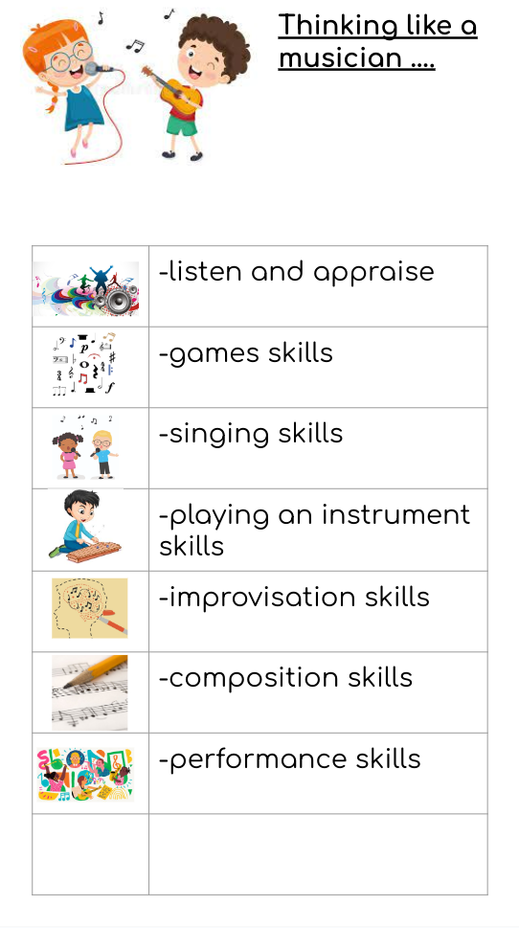

Unit | Skills | Knowledge
Musicianship  Understanding Music  Improvise Together | Listening  Finding a steady beat  Copy-back Improvisation Singing  Pulse/beat Rhythm Pitch Tempo Dynamics | - move in time with a steady beat.  - find the pulse of the music by moving my body.  - listen to, copy and repeat a simple rhythm through call and response.  - listen to, copy and repeat a simple melody using my voice.  - understand that the pulse or beat of the music is like a heartbeat that doesn’t stop.  - understand and can demonstrate that rhythm is a pattern of long and short sounds which are performed over the pulse of the music.  - sing high or low sounds, demonstrating an understanding of pitch.
Listen and Respond | Listening Responding Musical styles Historical context Different musicians  Pulse Rhythm Pitch Tempo Dynamics Timbre Texture Structure | - feel the pulse by moving my body to the music.  - say what I like or dislike about a piece of music and describe how it makes me feel.  - concentrate and listen to a piece of music.  - use some musical words to describe a piece of music.  - recognise some musical instruments and name them.  - recognise if the music is fast or slow.  - understand that tempo describes how fast or slow the music is.  - recognise if the music is loud or quiet.  - talk about the songs and pieces we have listened to and any songs that are similar.  - talk about different styles of music and where they might come from in the world.
Learn to Sing the Song | Singing/rapping Words and meaning Follow a leader Movement  Pulse Rhythm Pitch Tempo Dynamics Structure | - sing and/or rap as part of a group.  - demonstrate good posture when singing.  - sing some songs and sections of songs from memory.  - sing a solo, demonstrating some level of confidence.  - sing a solo with confidence.  - explain what the song is about.  - follow the leader of the group and take simple directions.  - add appropriate actions and movement to the songs I sing.
Play Your Instruments with the Song | Playing instruments Keeping a steady beat  Playing in a group/ensemble  Pulse Rhythm Pitch Tempo Dynamics Structure | - play a tuned and/or untuned percussion instrument carefully and with respect.  - rehearse a part effectively to improve my overall performance.  - play my instrument as part of an ensemble in time to a pulse and/or steady beat.  - perform repeated rhythmic patterns in time to a backing track.
Improvise with the Song | Improvising  Pulse Rhythm Pitch Tempo | - know that when I improvise, I am making up my own tune.  - use some notes to create an improvised rhythm/melody.  - stay in time with the music when I improvise.  - use call and response/question-and-answer to improvise simple vocal patterns.  - use rhythm and/or pitch to improvise over a steady pulse.
Compose with the Song  Create a Graphic Score | Composing  Pulse Rhythm Pitch Tempo Dynamics | - compose a melodic line with direction, creating a beginning and an end using the home key.  - explore pitch and rhythm when composing.  - evaluate my composition through performance, using up to five notes.  - write my melody using manuscript/online resources and/or graphic scores.  - recognise signs and symbols that equate to the note value of one and two beats.
Perform the Song | Performing Listening Following a leader Playing  Singing Improvising Composing Making decisions  Pulse Rhythm Pitch Tempo Dynamics Timbre Texture Structure | - perform the song with my class, without any help from the teacher.  - explain why we chose the song/s to perform.  - perform the song confidently with movement and/or actions.  - perform the song from memory.  - follow the leader or conductor.  - say what I liked or enjoyed about the performance and what could have been better.  - collectively plan a performance, including activities appropriate for an audience.  - explain the Musical Spotlight and how music and songs have a Social Theme, ie how music brings us together.

